

Use Case Specification: Training eCL Submission
For
eCoaching Log

Change History Log

Date | Version | Description | Author
03/16/2015 | 1.0 | Initial Document | Doug Stearns
04/03/2015 | 1.1 | P14512 – eCL Training Module  Updated 3.10 reasons and sub-reasons | Doug Stearns
06/10/2015 | 1.2 | P15075 – eCL Training Module Updates  Updated 3.10 sub-reason values | Doug Stearns
09/02/2015 | 1.3 | TFS667 – eCL WPOP70 submit all modules  Updated 7.1 – added WPOP70 to others | Doug Stearns
05/14/2016 | 1.4 | TFS2668 – eCL Sub-reason text change  Updated 3.10  Changed text for reason Level One Metric and SLA-Pass Rate | Doug Stearns
07/29/2016 | 1.5 | TFS3440 – eCL Job Code Submission Permission  Updated 7.1 | Doug Stearns

Table of Contents

1. Brief Description 6
2. Participating Actors 6
2.1 Primary 6
2.2 Secondary 6
3. Basic Flow of Events 7
3.1 Identify coachable event. 7
3.2 Access eCoaching Log website submission page. 7
3.3 Select Training module. 7
3.4 Select the appropriate Trainer (required selection). 7
3.5 Select where this behavior was observed. 7
3.6 Select the coaching delivery option (required selection). Select Yes to deliver coaching. 7
3.7 Progressive Disciplinary Warning is not available, however default to No. 7
3.8 Enter or select the date of coaching (required selection). 7
3.9 Select if Customer Service Escalation (required selection; default to No). 7
3.10 Select applicable coaching reasons, whether opportunity or reinforcement, and applicable sub-coaching reasons (required selection) 7
3.11 Enter details of the behavior to be coached (required entry; free form text up to 3000 characters). 11
3.12 Enter details from the coaching session including action plans developed (required entry; free form text up to 3000 characters). Note: Yes selected in 3.6 (not available if No selected). 11
3.13 Select how the coaching opportunity was identified (required selection). 11
3.14 Select if there is a Call Record associated with this coaching (required selection; default to No) 12
3.15 Select to verify that all information on the form is true and complete (required selection). 12
3.16 Submit the Training eCoaching Log. 12
3.17 System generates eCoaching eMail notification. 12
3.18 Employee (Trainer) receives system generated eMail notification of eCoaching Log when coaching is Direct and status is Pending Employee Review, then the eMail notification will use the following. 12
3.19 Employee (Trainer) selects hyper link to eCoaching Log Dashboard. 12
3.20 Employee (Trainer) uses eCoaching Log Dashboard to review and acknowledge logs. 12
4. Alternative Flows 13
4.1 Select the coaching delivery option. [Step 3.6] 13
4.2 Select if Customer Service Escalation. [Step 3.9] 13
4.3 Select if Call Record is associated with this coaching. [Step 3.14] 13
4.4 Pending Supervisor Review. [Step 3.18] 14
4.5 Pending Manager Review. [Step 3.18] 14
4.6 Pending Manager Review. [Step 4.5.4] 14
4.7 Pending Manager Review. [Step 3.18] 15
4.8 Pending Manager Review. [Step 4.7.4] 15
5. Preconditions 15
5.1 eCoaching Log website available. 15
5.2 eCoaching Log database available. 15
5.3 eCoaching Log database populated with correct and current hierarchy information for Trainers and Instructor, Training Supervisor and Training Manager. 15
6. Postconditions 15
6.1 eCoaching Log submitted. 15
6.2 eMail notifications sent appropriately. 15
7. Assumptions and Dependencies 16
7.1 Access to Training module will be limited to those with the following job codes: 16
Note: WTTR12, WTTR13, WTID13 can only submit logs to instructors with job code of WTTI02. 16
7.2 Basic from of eMail notification is as follows: 16
8. Business Rules 16
8.1 none 16
9. Technical Requirements 16
9.1 none 16
10. Activity Diagrams 17

Table of Figures
Figure 1 – Training eCL Submission 16

Brief Description
Allow eCoaching Logs for call center Trainers and Instructors.

Participating Actors

Primary

Trainers/Instructors

Training Supervisors

Training Managers

Secondary

N/A

Basic Flow of Events

Identify coachable event.

Access eCoaching Log website submission page.

Select Training module.

Select the appropriate Trainer (required selection).

Employees displayed will be those Trainers with job codes of WTTI02, WTTR12, WTTR13, WTID13.

Select where this behavior was observed.

Possible options are:
Production
Training
Other

Select the coaching delivery option (required selection). Select Yes to deliver coaching.

Possible options are:
Yes, I will be delivering the coaching session
No, I will not be delivering the coaching session

Progressive Disciplinary Warning is not available, however default to No.

Enter or select the date of coaching (required selection).

Select if Customer Service Escalation (required selection; default to No).

Possible options are:
Yes
No

Select applicable coaching reasons, whether opportunity or reinforcement, and applicable sub-coaching reasons (required selection)

Possible options are:
Coaching Reason | Opportunity and Reinforcement
- Sub-Coaching Reason
Attendance | Opportunity or Reinforcement
- Number of hours exceeded
- Number of occurrences exceeded
- Improper notification
- Late or missing meetings
- Other: Specify reason under coaching details.
Attrition Tracking | Opportunity or Reinforcement
- Inaccurate or missing information
- Other: Specify reason under coaching details.
Behavior | Opportunity or Reinforcement
- Communication is unprofessional in nature and/or offending to others
- Computer - Computer left unlocked
- Distraction of others (i.e. noisy, visiting)
- Dress Code
- GDIT Policy violation
- Harassment/Workplace Conduct
- Insubordination
- Privacy/Security
- SOP non-compliance
- Travel/AMEX policy
- Other: Specify reason under coaching details.
Classroom Documentation | Opportunity or Reinforcement
- Attendance/Corrective actions not coached timely
- DTR information not accurate
- Incomplete DTR
- Other: Specify reason under coaching details.
Classroom Management | Opportunity or Reinforcement
- Missed Level 1 goal - class
- Missed Level 1 goal - year
- Other: Specify reason under coaching details.
Confidentiality | Opportunity or Reinforcement
- Failed to keep sensitive information safe
- Other: Specify reason under coaching details.
CSR Completion of Required Training | Opportunity or Reinforcement
- CCO Learning for CSRs completed
- CCO MyLMS for CSRs completed
- Other: Specify reason under coaching details.
CSR Observations | Opportunity or Reinforcement
- Missed quarterly requirement
- Other: Specify reason under coaching details.
CUP & CCO Learning Completions | Opportunity or Reinforcement
- Deadline not met - per item
- Other: Specify reason under coaching details.
Emergency Response to Facility Alerts | Opportunity or Reinforcement
- Class/Instructor not in assigned area
- Other: Specify reason under coaching details.
ETS | Opportunity or Reinforcement
- Fails to review labor results/does not initiate correct action
- Missed approval deadline
- Not completed daily
- Wrong codes/times
- Other: Specify reason under coaching details.
Level One Metric | Opportunity or Reinforcement
- Metric - class
- Metric - month
- Metric - year
- Other: Specify reason under coaching details.
Media Policy | Opportunity or Reinforcement
- Local Media violation
- Other Media violation
- Social Media violation
- Other: Specify reason under coaching details.
Misreporting | Opportunity or Reinforcement
- DTR
- Exam Review
- Level 1
- Other
- Resume
- Timecard
- WSR
- Other: Specify reason under coaching details.
MyLMS Completions | Opportunity or Reinforcement
- Deadline not met
- Other: Specify reason under coaching details.
Operations Support | Opportunity or Reinforcement
- Assigned to committee - inactive
- Disregards needs and issues/fails to report issues
- Does not participate actively within the call center
- Failed to respond to request to take calls
- Fails to provide continued support to improve Training completions
- Fails to respond to assigned Supervisors' team needs
- Missed taking calls quarterly requirement
- Training buddy system not assigned or not working
- Other: Specify reason under coaching details.
Peer Observations | Opportunity or Reinforcement
- Failed to complete assignments - per class
- Other: Specify reason under coaching details.
Personal ETS | Opportunity or Reinforcement
- Missed signature deadline
- Not completed daily
- Wrong codes/times
- Other: Specify reason under coaching details.
Recognition | Reinforcement
- Actively participates in call center activities and committees
- Attendance - Attends meetings as scheduled
- Attendance - Perfect Attendance
- CSR ETS - Correctly executed - weekly ETS
- CSR Observation - Exceeded Quarterly requirements
- Classroom Metric SLA Goal achieved-Class/Monthly/Year
- Level One SLA - Exceeded goal -Class/Monthly/Year
- Met CUP/CCO Learning Completions Deadline As Verified
- No violations - per sweep
- Operations Support - Is proactive to report needs and issues
- Operations Support - Proactively supports assigned Supervisors
- Peer Observation - Exceeded assignments - per class
- Personal ETS - Correctly executed - weekly
- Trainer Observation - Meets or exceeds guidelines
- Weekly Status - Perfect Monthly Compliance
- Weekly Status Report - Perfect monthly compliance
- Other: Specify reason under coaching details.
RTW | Opportunity or Reinforcement
- Missed yearly pass rate metric
- RTW Summary Page information not accurate/missing information
- Other: Specify reason under coaching details.
Secure Floor Violations | Opportunity or Reinforcement
- Badge Policy
- Cell phone/electronic device
- Clean desk
- Computer - Computer left unlocked
- Fails to report known issue
- Food
- Misuse of desk or locker
- Unlocked training room, desk, filing cabinet
- Other: Specify reason under coaching details.
SLA-Pass Rate | Opportunity or Reinforcement
- Metric - class
- Metric - month
- Metric - year
- Other: Specify reason under coaching details.
Taking Calls | Opportunity or Reinforcement
- Failed to respond to request
- Missed quarterly requirement
- Other: Specify reason under coaching details.
Trainer Development | Opportunity or Reinforcement
- Behavior training
- Classroom deadlines
- ETS - timesheets and attendance
- Presentation Skills
- Trainer CUP & CCO Learning completions
- Trainer MyLMS completions
- Trainer On-boarding
- Trainer WSR completion
- Other: Specify reason under coaching details.
Trainer Expectations | Opportunity or Reinforcement
- Alias names
- Bilingual Certification not completed as outlined for bilingual CSRs
- CCO Learning & MyLMS for CSRs completed
- Class Confirmations
- ETO e-mail
- Filing hard copies of certification documents
- On-boarding
- Ops Summary e-mail (from DTR)
- Other: Specify reason under coaching details.
Trainer Observations | Opportunity or Reinforcement
- Fails to meet SOP
- Other: Specify reason under coaching details.
Weekly Status Report | Opportunity or Reinforcement
- Incomplete/Inaccurate
- Missed deadline
- Other: Specify reason under coaching details.

Enter details of the behavior to be coached (required entry; free form text up to 3000 characters).

Enter details from the coaching session including action plans developed (required entry; free form text up to 3000 characters). Note: Yes selected in 3.6 (not available if No selected).

Select how the coaching opportunity was identified (required selection).

Possible options are:
CMS Reported Item
CSR Reported Issue
Classroom Observation
Floor Walking
Internal CCO Reporting
Leadership Listening
Manager Coaching
Quality Call Listening
Supervisor Coaching

Select if there is a Call Record associated with this coaching (required selection; default to No)

Possible options are:
Yes
No

Select to verify that all information on the form is true and complete (required selection).

Submit the Training eCoaching Log.

System generates eCoaching eMail notification.

Employee (Trainer) receives system generated eMail notification of eCoaching Log when coaching is Direct and status is Pending Employee Review, then the eMail notification will use the following.

Subject:
eCL: Pending Employee Review (<EMPLOYEE NAME>)
Message:
A new eCoaching Log has been entered on your behalf. Please click on the link below to review and verify the coaching opportunity received on <DATE>.

Employee (Trainer) selects hyper link to eCoaching Log Dashboard.

Employee (Trainer) uses eCoaching Log Dashboard to review and acknowledge logs.

Alternative Flows

Select the coaching delivery option. [Step 3.6]

Select No to not deliver coaching session.

Continue with steps 3.7 through 3.11 above, skip 3.12.

Continue with Step 3.13 above.

Select if Customer Service Escalation. [Step 3.9]

Select Yes is a Customer Service Escalation

Coaching Reason of Customer Service Escalation is automatically selected and disabled.

Select applicable Sub-coaching Reasons

Possible options are:
Coaching Reason | Opportunity and Reinforcement
- Sub-Coaching Reason
Customer Service Escalation | Opportunity
- Argues with other trainer
- Encourages / commits fraud
- Compromises PHI/PII
- Releases assessment information to the CSRs in class
- Threatens employee
- Uses derogatory / disrespectful words
- Uses profanity of any kind
- Verbally abusive
- Yells, screams
- Other: Specify reason under coaching details.

Continue with Step 3.11 above.

Select if Call Record is associated with this coaching. [Step 3.14]

Select Yes call record is available.

Select the applicable call record source

Possible options are:
Verint
NGD ID
Avoke
UCID

Enter the appropriate identifier value for selected option

Continue with Step 3.15 above

Pending Supervisor Review. [Step 3.18]

Training Supervisor (receives system generated eMail notification of eCoaching Log when coaching is Indirect and status is Pending Supervisor Review then the eMail notification will use the following:.

Subject:
eCL: Pending Supervisor Review (<EMPLOYEE NAME>)
Message:
A new eCoaching Log has been entered on behalf of <EMPLOYEE NAME> on <DATE> that requires your action. Please click on the link below to review the eCoaching log.

Training Supervisor selects hyper link to eCoaching Log Dashboard.

Training Supervisor uses eCoaching Log Dashboard to review coaching logs.

Pending Manager Review. [Step 3.18]

Manager receives system generated eMail notification of eCoaching Log when coaching is Direct and is a Customer Service Escalation and status is Pending Manager Review then the eMail notification will use the following:
Subject:
eCL: Pending Manager Review (<EMPLOYEE NAME>)
Messge:
A new eCoaching Log has been entered and requires your action. Please click on the link below to review and verify that the eCL entered on <DATE > for <EMPLOYEE NAME> is a valid Customer Service Escalation (CSE). Further directions are provided on the form.

Manager selects the hyper link to eCoaching Log Dashboard.

Manager selects the appropriate eCoaching Log to review.

Manager selects Yes to confirm it is a Customer Service Escalation (required).

Manager selects or enters date coached (required).

Manager enters coaching detail (required; free form text up to 3000 characters).

Manager submits eCoaching Log review.

Status of eCoaching Log becomes Pending Supervisor Review.

Pending Manager Review. [Step 4.5.4]

Manager selects No to confirm it is not a Customer Service Escalation (required).

Manager selects or enters date reviewed (required).

Manager enters reason not a Customer Service Escalation (required; free form text up to 3000 characters).

Continue with step 4.5.7 above.

Pending Manager Review. [Step 3.18]

Manger receives system generated eMail notification of eCoaching Log when coaching is Indirect and is a Customer Service Escalation and status is Pending Manager Review then the eMail notification will use the following:
Subject:
eCL: Pending Manager Review (<EMPLOYEE NAME>)
Message:
A new eCoaching Log has been entered and requires your action. Please click on the link below to review and verify that the eCL entered on <DATE> for <EMPLOYEE NAME> is a valid Customer Service Escalation (CSE). Further directions are provided on the form.” form.

Manager selects the hyper link to eCoaching Log Dashboard.

Manager selects the appropriate eCoaching Log to review.

Manager selects Yes to confirm it is a Customer Service Escalation (required).

Manager selects or enters date coached (required).

Manager enters coaching detail (required; free form text up to 3000 characters).

Manager submits eCoaching Log review.

Status of eCoaching Log becomes Pending Supervisor Review.

Pending Manager Review. [Step 4.7.4]

Manager selects No to confirm it is not a Customer Service Escalation (required).

Manager selects or enters date reviewed (required).

Manager enters reason not a Customer Service Escalation (required; free form text up to 3000 characters).

Continue with step 4.7.7 above.

Preconditions

eCoaching Log website available.

eCoaching Log database available.

eCoaching Log database populated with correct and current hierarchy information for Trainers and Instructor, Training Supervisor and Training Manager.

Postconditions

eCoaching Log submitted.

eMail notifications sent appropriately.

Assumptions and Dependencies

Access to Training module will be limited to those with the following job codes:
Trainer | WTTI02, WTTR12, WTTR13, WTID13
Training Supervisor | WTTR40
Training Manager | WTTR50
Others | WPOP70, Program Staff Systems Analyst, Software Engineer, Testing Engineer

Note: WTTR12, WTTR13, WTID13 can only submit logs to instructors with job code of WTTI02.

Basic from of eMail notification is as follows:

To – [strto]
Subject – [strSubject]
** This is an automated email. Do not reply to this email. **
[strCtrMessage]
Please click here to open the coaching application and select the 'My Dashboard' tab to view the below form ID for details. [Link to Dashboard]
Form ID: [strFormID]
(Please do not respond to this automated notification)
Thank you,
eCoaching Log Team


Business Rules

none

Technical Requirements

none

Activity Diagrams
Below is the activity diagram for the use case that provides a visual depiction of the flow of events.

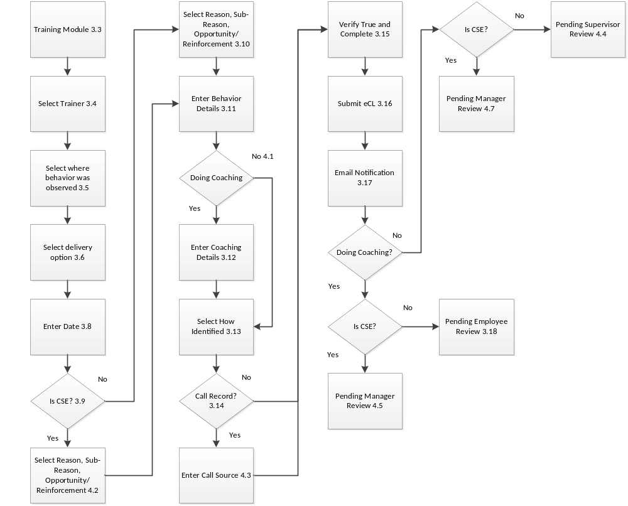

Figure 1 – Training eCL Submission

